### **Web/ Cloud Programming**

### CSEE5590 Spring 2018

Lab-1 Report

Hemanth Kumar Reddy Dantu

Class Id:12

16233525

**Requirement:**

To create a web page so that a student can select the course, term and his major and can register for a subject.

**Tools Used:**

* HTML
* JavaScript
* CSS

**Procedure:**

For the Home Page I used the radio buttons to select the course, Term, and the Subject, Upon searching, based on the combination of the selected fields the page is redirected accordingly.

Radio buttons, Html form are used to construct this page

JavaScript code algorithm was written to redirect the page to a different page based on the selected combination

The University Registration button on the top of every page is responsive to take the user to the home page.

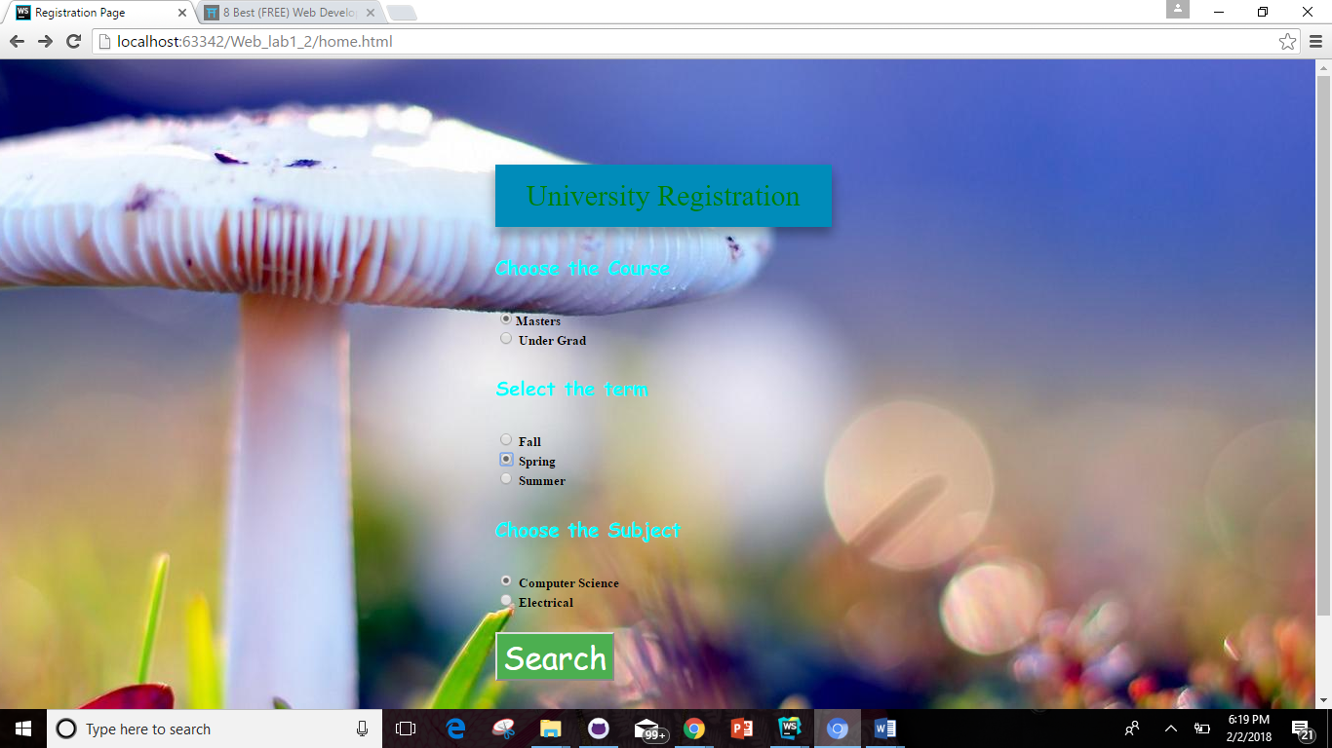

Tables are used to construct this page and href are used to navigate to the final registration page.

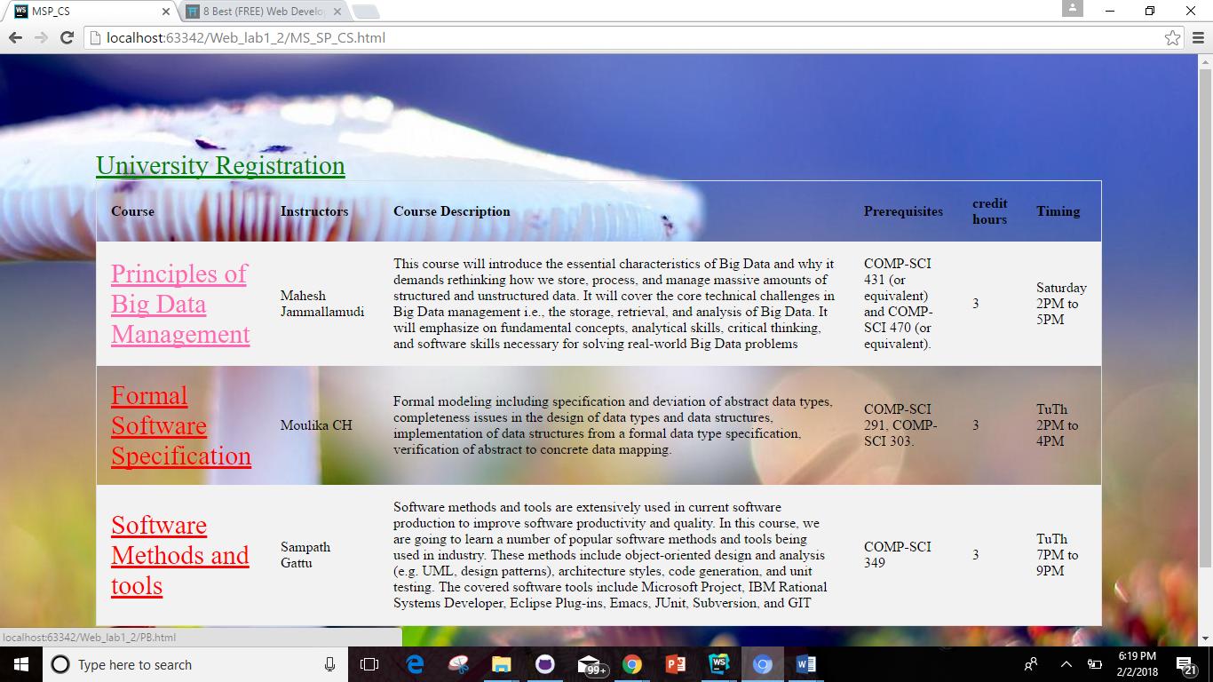



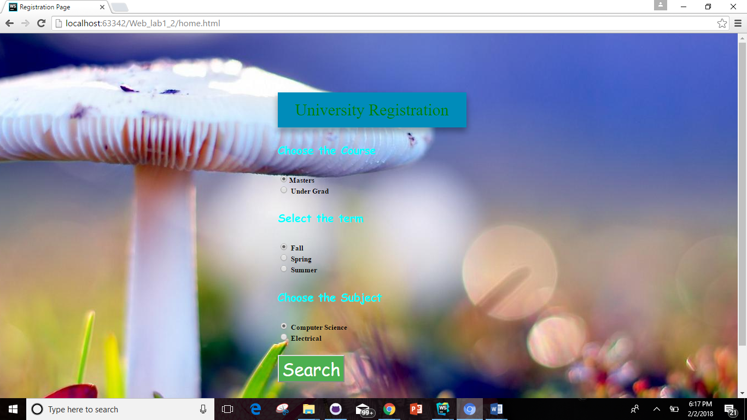

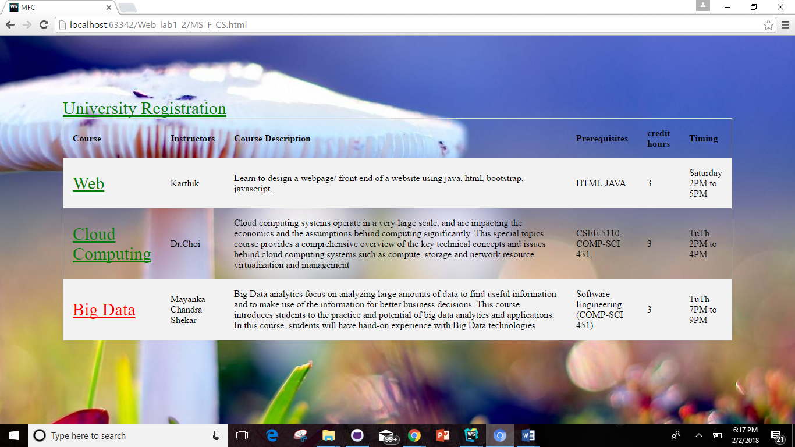



By clicking on register student gets registered to the class and thereby the number of seats in the class decreases.



By Clicking on the link for online course relevant course will be opened in a new tab.

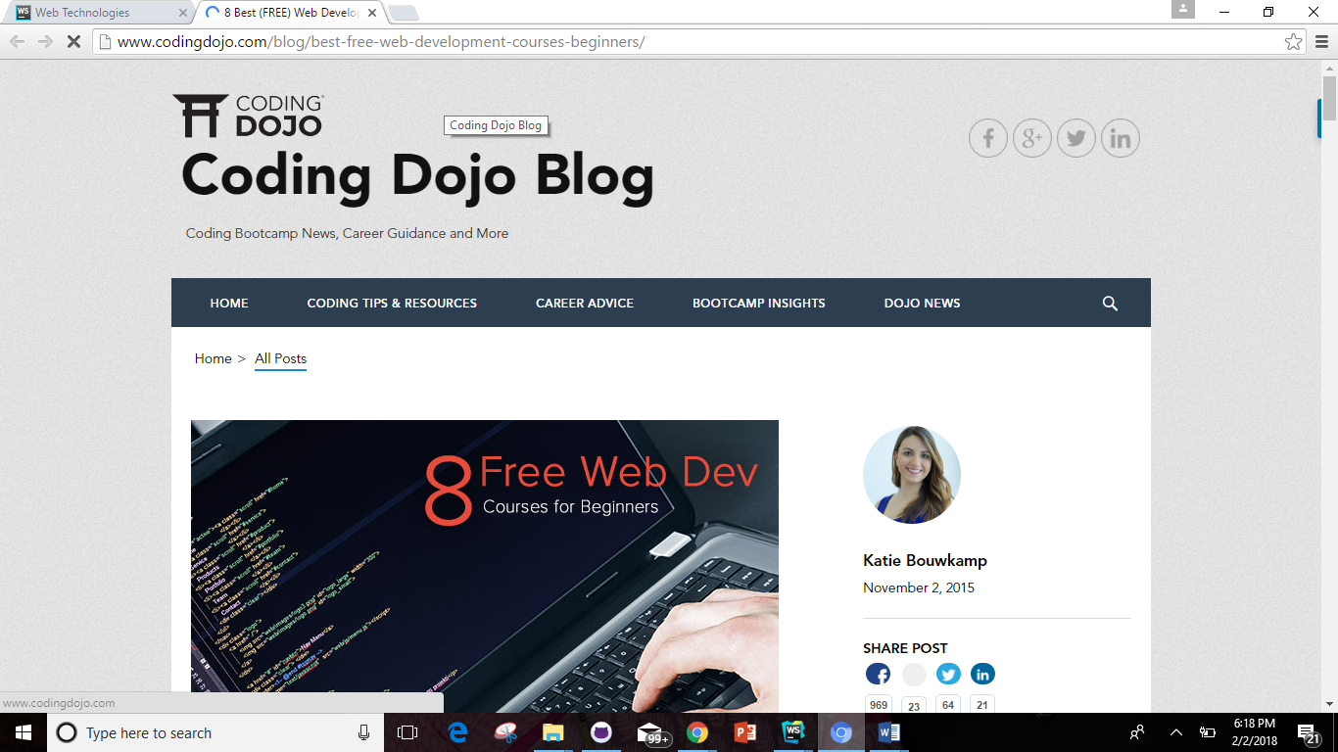



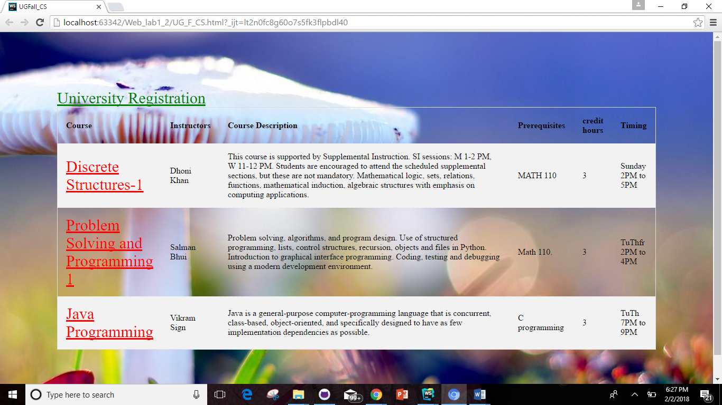

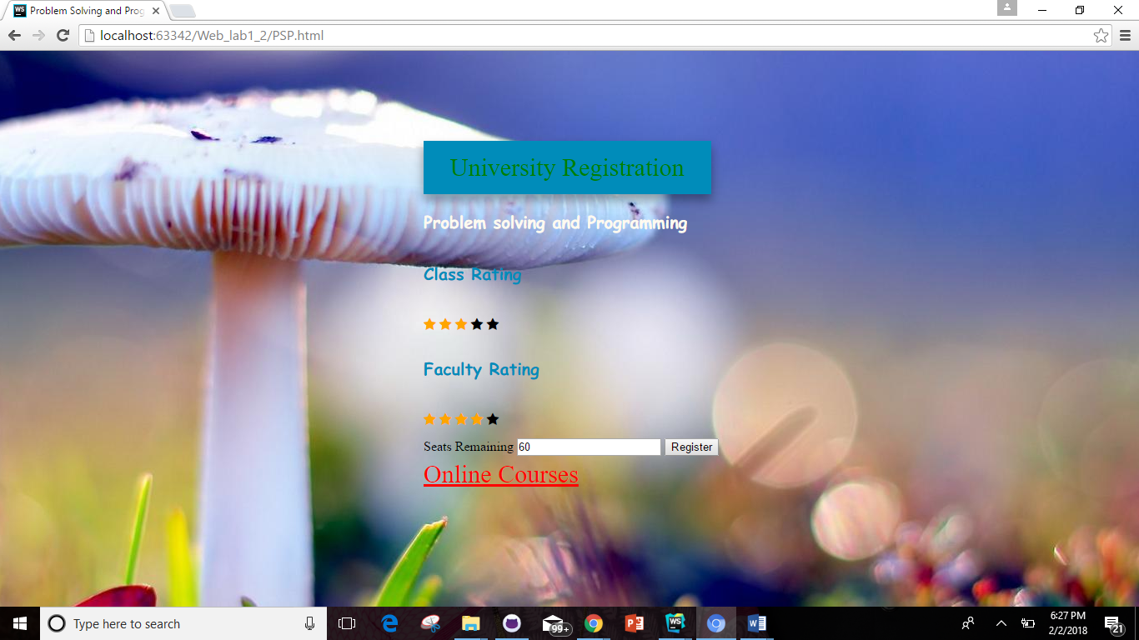

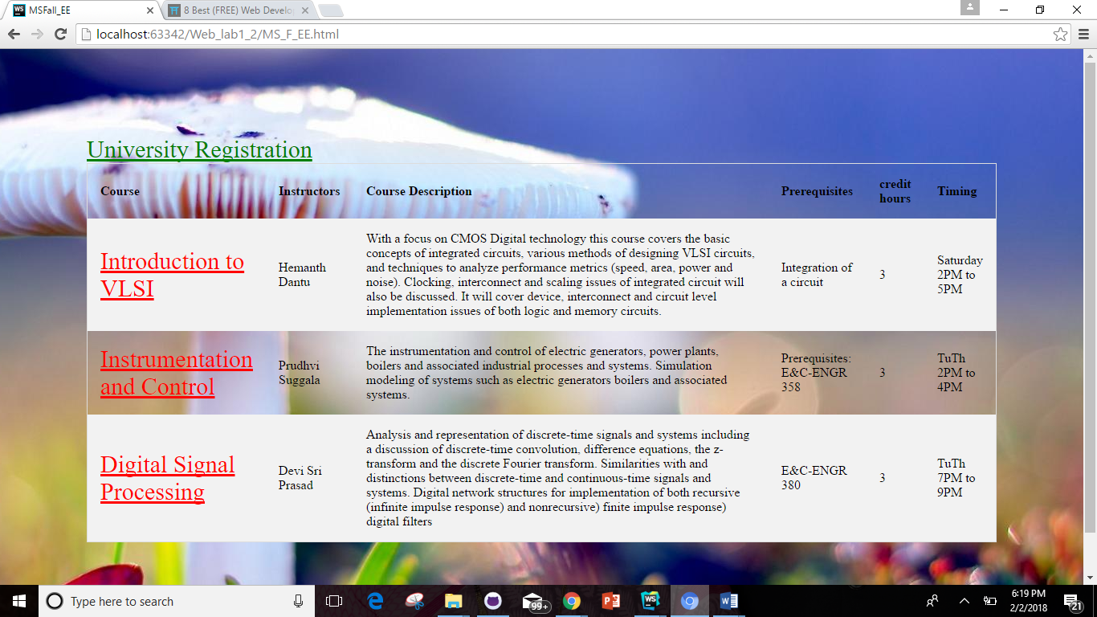



References:

[www.w3schools.com](http://www.w3schools.com)

[www.codepen.org](http://www.codepen.org)

[www.jsfiddle.net](http://www.jsfiddle.net)